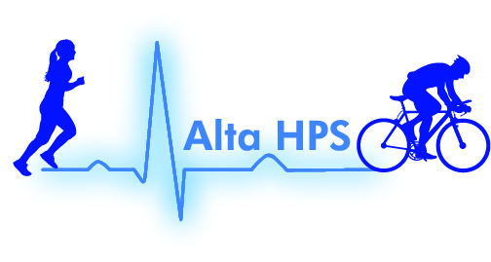
Alta Health and Performance Solutions

Payment Arrangements Agreement

Please read and complete with signature and date indicating your understanding and acknowledgment of the following terms:

- Full payment must be received prior to commencement of performance test.
- Forms of payment include cash, Mastercard, Visa, and PayPal either online or in person.
- A Cancellation fee of $100 will be assessed for failure to show up or if you cancel your appointment with less than 24 hours advance notice. Subsequent visits will only be permitted with receipt of cancellation fee a minimum of 48 hours prior to scheduling appointment.
- Minimum cancellation period for full refund is 48 hours. If cancellation occurs between 48 hours and 24 hours a $50 fee will be assessed. This fee must be paid prior to scheduling future appointments.

